Chalk Talk: Photosynthesis
AP Biology

Photosynthesis
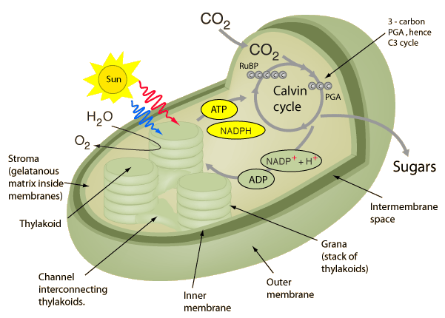
Have you hugged a tree lately? If not, you might want to give it some thought. You, along with the rest of the human population, owe your existence to plants and other organisms that capture light. In fact, most life on Earth is possible because the sun provides a continuous supply of energy to ecosystems.
All organisms, including humans, need energy to fuel the metabolic reactions of growth, development, and reproduction. But organisms can't use light energy directly for their metabolic needs. Instead, it must first be converted into chemical energy through the process of photosynthesis.

Photosynthesis is the process in which light energy is converted to chemical energy in the form of sugars. In a process driven by light energy, glucose molecules (or other sugars) are constructed from water and carbon dioxide, and oxygen is released as a byproduct. The glucose molecules provide organisms with two crucial resources: energy and fixed—organic—carbon.
(Source: Khan Academy)

Driving Question: Plants need energy to stay alive and grow. How do you think plants get energy?

Task: Using whiteboard markers to construct a model of the chloroplast, mainly the thylakoid membrane and the stroma, on your desk. Make sure to label and describe the following structures, functions, molecules, and processes in your model.
- Light-dependent reaction  - Light  - Chlorophyll  - Photon  - Photolysis  - Photosystem I  - Photosystem II  - Thylakoid membrane  - Electrons  - Electron transport chain  - Chemiosmosis  - ATP synthase | - NADPH  - NADH⁺  - ADP  - ATP  - Protons (H⁺ ions)  - H₂O  - O₂  - Proton gradient  - Active transport  - Facilitated diffusion | - Light-independent reaction (Calvin cycle)  - CO₂  - Glucose (C₆H₁₂O₆)  - Carbon fixation  - RuBisCo  - RuBP  - Reduction  - 3-PGA  - G3P  - Regeneration

Deliverable: Create a summary/concept map for ‘Photosynthesis’ on a piece of A3 paper. Examples as follows:
